**LAMPIRAN B**

ENVIRONMENT UJI COBA

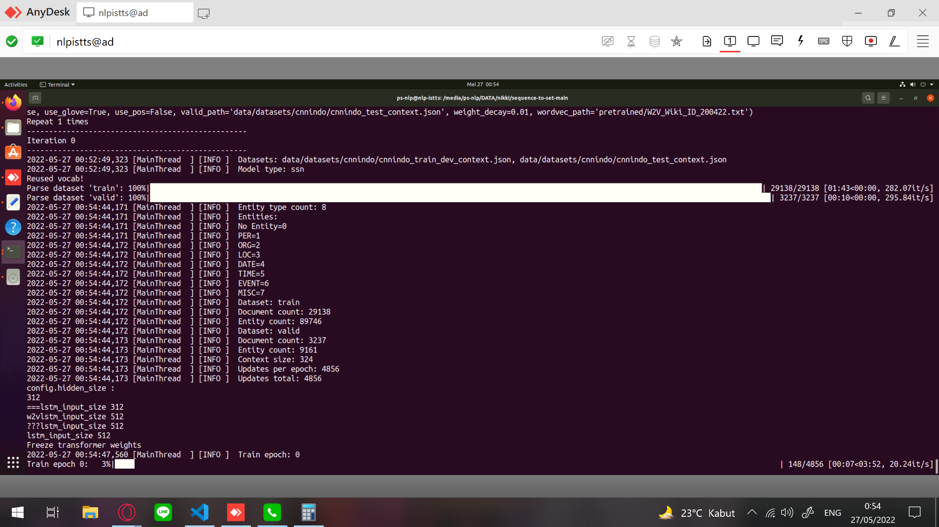

**Gambar A.1**

**Environment Linux**

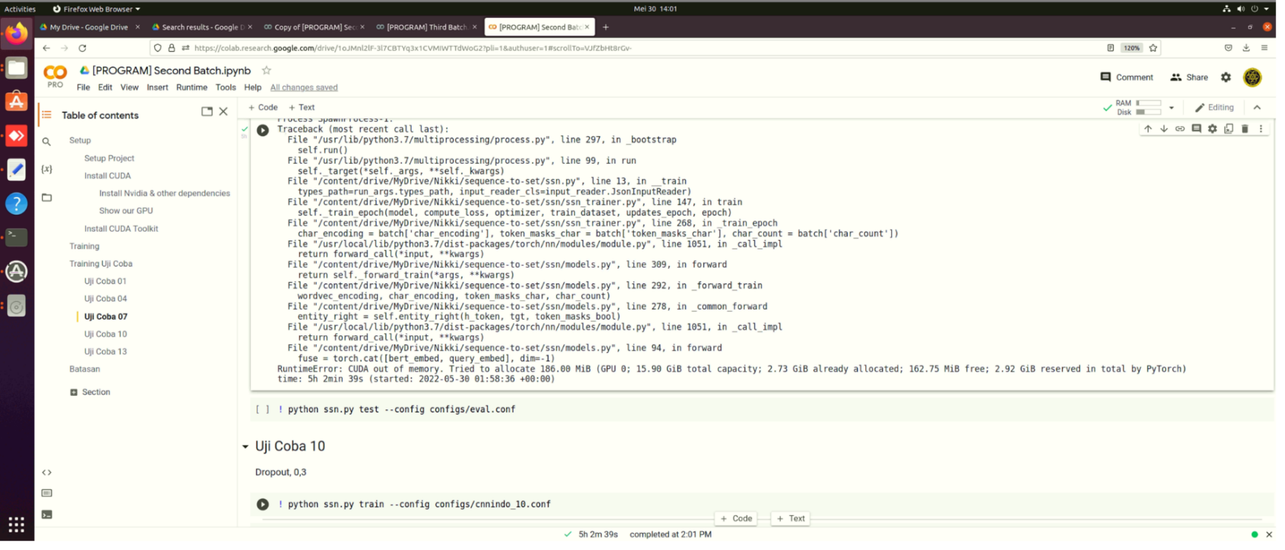

**Gambar A.2**

**Google Colab – Error: CUDA out of memory**

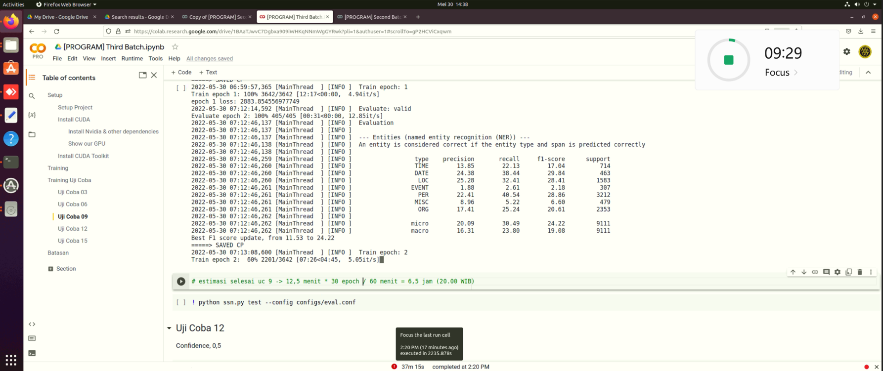

**Gambar A.3**

**Google Colab – Error: Unexpected error**

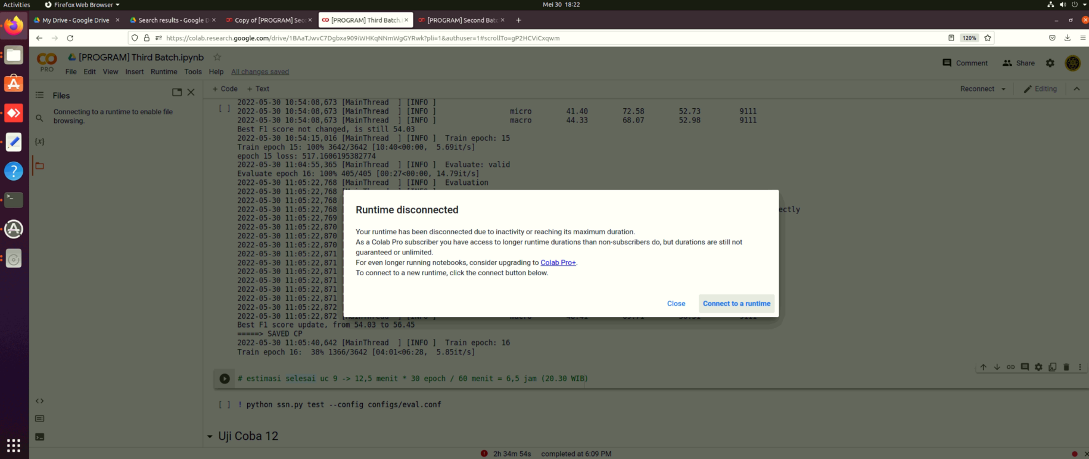

**Gambar A.4**

**Google Colab – Error: Runtime Disconnected**